gc_logo_small

\_\_\_\_\_\_\_\_\_\_\_\_\_\_\_\_\_\_\_\_\_\_\_\_\_\_\_\_\_\_\_\_\_\_\_\_\_\_\_\_\_\_\_\_\_\_\_\_\_\_\_\_\_\_\_\_\_\_\_\_\_\_\_\_\_\_\_\_\_\_\_\_\_

**Advising the Affluent Client:**

**Banking Strategies**

© 2016 Greene Consulting Associates, LLC INTENDED SOLELY FOR USE BY REGISTERED USERS NOT TO BE REPRODUCED OR CIRCULATED

## ABOUT GREENE CONSULTING ASSOCIATES, LLC

Greene Consulting Associates was founded in 1979 and provides consulting and training services solely to the financial services marketplace. Located in Atlanta, Georgia, Greene Consulting has worked with the top providers of investment management and wealth management in both the United States and abroad. Focused on helping firms generate incremental revenue growth through more effective sales and relationship management strategies, Greene Consulting offers customized training programs in Financial Services Sales, a Sales Management program, Presentation Training that integrates proprietary products, and a comprehensive suite of online learning courses related to investments and wealth management.

For more information about Greene Consulting or any of its products and services, write Greene Consulting at Waterstone Building, 4751 Best Road, Suite 450, Atlanta, Georgia 30337. Or, visit the company's website at www.greeneconsults.com.

## Introduction

At the heart of many affluent client relationships are the banking solutions - deposit accounts, home equity lines, mortgages and other loans - that address their most traditional financial needs. However, affluent clients obviously have a wide range of other financial needs as well, including investment planning, retirement planning, education and estate planning needs that must likewise be addressed with the same degree of care and expertise. To retain and grow relationships with affluent clients, advisors must:

* Proactively identify banking solutions that address their client’s needs
* Leverage the information they have on banking clients to identify additional planning needs beyond banking solutions

|  |
| --- |
| Objectives  This course has been structured to equip advisors with effective strategies for identifying opportunities to proactively engage clients on key planning topics and deliver more comprehensive solutions. Specifically, this course addresses three key objectives:   * How to proactively identify opportunities to address clients’ banking needs. * How to engage clients and prospects in more effective, advice-centered conversations about banking solutions. * How to leverage basic sources of client information to quickly identify additional planning opportunities. |

Adobe Reader

This course incorporates files saved in Acrobat Reader. To get the most from this course, you will need to view and print these files. If you do not have Adobe Reader, it may be downloaded free of charge by clicking the following link:

<http://www.adobe.com/products/acrobat/readstep2.html>.

## Understanding the Affluent Client Mindset

It certainly is no surprise that affluent clients represent an attractive and potentially profitable segment of the market. Although this fact is intuitively obvious, consider the following statistics:

* There are over 77 million affluent individuals in the United States1
* Affluent clients have an average of three (3) banking relationships2
* 93% of affluent clients own homes
* 58% of affluent clients have a mortgage
* 97% of affluent clients have credit cards and spend on average more than 55% more than the average credit card user

However, capitalizing on opportunities with this important segment of the market requires professionals to more fully understand how these individuals think and make financial decisions.

|  |
| --- |
| **Example**   * 93% of affluent clients cite “Quality of Advice” as highly important in the process of selecting a financial provider.2 * Yet over 55% of affluent clients cited a level of dissatisfaction with the current level of advice they were receiving from their advisor(s).2 * Of self-directed affluent clients, 21% cited “no reason” when asked why they stay with their primary financial services institution, highlighting an alarming sense of apathy and, ultimately, risk for organizations targeting this segment of the market. 2 |

When taken in context, the message is clear. Affluent clients represent a highly attractive segment of the marketplace from a financial perspective and, more important, are seeking more proactive financial advice than they are getting today. Capitalizing on this opportunity will require advisors to enhance their approach to engaging these clients on the key financial issues of relevance to them, expanding the breadth and depth of the advice that is delivered.

*1 Market Rates Insight*

*2 The Spectrem Group*

## The Importance of Being Proactive

In any case, banking solutions (ranging from basic deposit and checking accounts to mortgages and home equity lines of credit) constitute the core component of the relationship with the client. Once an area completely owned by banking institutions, banking services are now being offered by everyone from brokerage firms such as Merrill Lynch to insurance companies such as State Farm. One of the primary reasons for this increased competition to provide banking solutions is the fact that the banking relationship is so important to many clients, serving as a gateway to developing a deeper, more holistic relationship.

Recognizing the intensifying competition in the banking arena, advisors in today’s market must be more effective than ever in identifying opportunities to proactively deliver thoughtful banking solutions. This means that advisors must be able to more effectively manage their relationships, responding to traditional servicing needs and requests, while also proactively identifying planning opportunities.

Simply put, those who fail to proactively engage clients to identify banking opportunities are at risk of losing the relationship to competitors.

## Focusing on Common Banking Needs

The first step in establishing a structure for delivering proactive banking solutions to affluent clients is to understand the most common banking needs of this segment of the marketplace. While many of the needs are no different than any other segment, affluent clients are unique in their need and ability to take advantage of more than just traditional solutions.

In the pages that follow, we will examine the most common banking needs of affluent clients and, more important, define effective strategies for proactively engaging these clients in thoughtful conversations about these issues in an effort to serve a broader range of their needs.

While certainly not all-inclusive, the needs below are the most common issues you will encounter when working with affluent clients.

|  |
| --- |
| **Most Common Issues**   * Issue #1: Inconvenient / Ill-Coordinated Banking Relationships * Issue #2: Failure to Optimize Yield on Short-term Deposits * Issue #3: Improper Structure on Loans * Issue #4: Tax-Inefficient Access to Liquidity |

These issues are discussed individually with the goal of equipping you with the requisite knowledge and strategies to ensure that your clients are not falling prey to these common mistakes.

## Issue #1: Inconvenient / Ill-Coordinated Banking Relationships

It comes as no surprise that one of the more important factors in gaining greater loyalty and commitment from affluent clients is serving their banking needs in the most convenient manner possible. In fact, a recent survey by JD Power and Associates (Figure A) found that timely service in the branch had the most significant impact on customer satisfaction. Certainly, convenience is not measured in terms of time to handle a transaction alone; however, this survey simply serves to confirm the obvious - affluent clients are typically busy people seeking to simplify their lives in any way possible.

|  |  |  |  |  |  |  |  |  |
| --- | --- | --- | --- | --- | --- | --- | --- | --- |
| **Figure A**   |  |  | | --- | --- | | **Issue** | **Impact on Satisfaction Score\*** | | Waiting less Than 5 minutes in Branch | **70** | | 24-hour Access to Account Info | **57** | | No ATM Failures | **42** |   *\* JD Power Index Points* |

Another interesting insight is the fact that, according to The Spectrem Group, affluent households have an average of three (3) banking relationships. Having multiple banking relationships requires individuals to take time in coordinating these relationships, which often results in a degradation of convenience. Advisors who are able to both respond efficiently to client needs and proactively identify additional issues that will ease their financial burdens will create greater client loyalty and commitment.

Recognizing the importance of convenience to affluent clients and the fact that many of these households have accumulated multiple banking relationships, the question becomes “How do I engage my clients to capitalize on this opportunity to serve them in a more convenient manner?” The following are effective questions you can use to get clients to recognize how you can address this importance need.

|  |
| --- |
| **Effective Questions**   * Who do you bank with currently? * What do you value in these relationships? * What changes would you make? * How do they work with you to ensure your banking experience is convenient? * How do you coordinate your numerous banking relationships to ensure you are being well served? |

Asking questions such as these will give you meaningful insight into how you can serve your clients more effectively, and, in many cases, identify opportunities for you to consolidate relationships from other providers.

## Issue #2: Failure to Optimize Yield on Short-Term Deposits

A second issue that is highly relevant to the affluent client is managing short-term deposits to ensure they are getting optimal yields on these balances. Relative to this issue, one of the first questions you should ask yourself is “Do I know how much this household holds in short-term deposits?” Before you answer this question, consider the following:

* Do they have brokerage accounts in which they trade securities?
* Do they have mutual fund accounts?
* What other banking relationships do they have?
* Who do their children bank with currently?

When you begin to consider these other sources of short-term deposits, it becomes more apparent that often the total short-term cash balances that affluent clients hold is much higher than they realize. Additionally, failure to proactively manage these balances will result in less than optimal yields on these assets. Even modest increases in yields on cash reserve assets can add up and make a noticeable difference over time.

Following are some effective strategies for identifying opportunities to capture additional deposits.

|  |
| --- |
| **Effective Questions**   * Including brokerage accounts, mutual fund accounts and other banking relationships you have, how much do you currently hold in short-term assets/deposits? * How do you manage these short-term assets to optimize your yield? * How much time do you spend in managing these assets every month? * What alternatives to your current strategy have you considered to ensure you are optimizing the yield on these balances? |

## Issue #3: Inappropriately Structured Loans

A third and very important issue impacting affluent clients is ensuring their outstanding loans are properly structured. Interestingly, according to the IRS, affluent clients account for over 70% of outstanding mortgage balances in the United States. This fact, coupled with the uncertain interest rate environment, underscores the relevance and importance of ensuring these debt balances are properly structured.

Although this issue may be common sense to you as a financial services professional, the fact of the matter is that many affluent clients are at risk due to potentially ill-structured loans. In fact, a recent survey by BAI found that over 25% of mortgages today are Adjustable Rate Mortgages (ARMs), of which over 11 million will reset in the next two years. Although no one can predict where interest rates will go over the next few years, failure to review loan structures to ensure they remain appropriate is a necessity for all affluent clients.

To help clients understand the impact of rising interest rates on their loan balances, convert the complexities of a mortgage into simple dollars and cents.

|  |  |  |  |  |  |  |  |  |  |
| --- | --- | --- | --- | --- | --- | --- | --- | --- | --- |
| **Mortgage Example**  An individual with a 30-year fixed rate mortgage with a balance of $300,000 will save $4,513.73 every year by simply converting from an 6.5% to a 4.5% mortgage.   |  |  |  | | --- | --- | --- | | 4.5% Payment | = | $1,520.06 | | 6.5% Payment | = | $1,896.20 | | Savings | = | **$4,513.73 every year** ($135,412 over the term of the mortgage) | |

Using simple questions such as the ones in the example below, in combination with some of the statistics cited above, can be extremely helpful in engaging clients to identify new loan opportunities.

|  |
| --- |
| **Effective Questions**   * What is the structure of your current mortgage? * What other outstanding loan balances do you have currently? * In today’s rising interest rate environment, how do you review these outstanding loan structures to ensure they are the best options for you? |

## Issue #4: Tax-Inefficient Access to Liquidity

A final issue of relevance to affluent clients is their ability to access liquidity in the most tax-efficient manner possible. It is highly unlikely that you will ever encounter an individual who is not interested in reducing their tax burden; however, many affluent clients fail to consider how to access liquidity in the most tax-efficient manner possible.

For example, the average household in the United States has an outstanding credit card balance of over $15,799\* and, according to Bankrate.com, the average variable interest rate on credit cards fluctuates near 16% as of March 2015. As of April 2014, total U.S. consumer debt is about $3.1 trillion (Source: Federal Reserve's G.19 report on consumer credit, released April 2014). Additional statistics would only further suggest that there is a tremendous opportunity to provide objective assistance to help people more efficiently manage their cash and consumer debt. To capitalize on this potential opportunity, consider the following engagement questions below.

|  |
| --- |
| **Effective Questions**   * What are the total outstanding balances you are currently carrying on your credit cards? * What is the average interest rate you are paying on these balances? * What alternatives have you considered for lowering the rate on these balances? * How have you determined this is the most tax-efficient way to generate needed liquidity? |

These questions will enable you to learn more about your client’s financial situation and potentially uncover opportunities to address important financial needs they may have.

*\* Source: U.S. Federal Reserve, July, 24, 2012*

*\*\* When discussing tax-related issues with clients or prospects, it is important that you not provide any tax advice. Clients should be encouraged to seek the counsel of their tax advisor before making changes.*

## Providing Proactive Banking Advice

The preceding pages of this course have addressed some of the common banking needs of affluent clients, examining them in a relatively detailed fashion. The purpose of this detailed analysis is to focus your efforts on common needs, equip you with effective strategies for engaging your clients in advisory conversations by using targeted questions, and finally, provide you with statistics and surveys that you can use to establish the relevance and impact of addressing these issues.

Recognizing the time required to proactively contact clients to discuss all of these issues could be prohibitive, consider the following strategy.

|  |
| --- |
| **Step One: Assess Five (5) Relationships** |
| Assess each relationship by asking yourself the following questions:   * Do I know all of the organizations they bank with currently? * Do I know how much they currently hold in short-term deposit balances? * Am I sure they have no needs for liquidity in the next 12 months? * Am I sure they have reviewed their current outstanding loan structures to ensure they remain appropriate? |
| **Step Two: Develop a Call Plan** |
| If you cannot answer any one or more of these basic questions, simply review the Engagement Questions in this course to develop your call plan. For each issue, simply prepare 2-3 effective questions that will get you into an advisory-oriented conversation with the client. |
| **Step Three: Execute** |
| Pick up the phone and contact your clients. You can start by simply saying:  “I was just taking some time to review your accounts and felt I needed to talk with you. Can you spend just a couple of minutes with me right now?”  This process is simple, providing you an effective strategy that will demonstrate your commitment to the relationship and potentially identify additional opportunities to serve your clients in a more comprehensive manner. |

## Identifying Additional Planning Opportunities with Banking Clients

In addition to serving the banking needs of your clients, it is becoming increasingly important to likewise engage your clients on other financial planning issues of importance to them as well. However, there are times when it can be challenging to get clients to open up and share relevant information with you. There are many reasons why a client may be unwilling to share financial information with you.

|  |
| --- |
| **Typical Reasons for an “Unwilling” Client**   * “I don’t have time right now to discuss it.” * “You are my banker; I look to you for assistance with financial transactions and loans. My broker and CPA handle all my financial planning needs. Why do you want to know about these issues?” * They simply fear revealing information that will be used to “sell them something”. |

Whatever the reason, one fact remains the same - you need basic financial information to provide the insights and guidance your affluent clients want and expect. Understanding this challenge, the question becomes, “Where can I go to quickly uncover valuable information that I need to identify potential planning opportunities with my clients?” The answer is simple - IRS Form 1040.

While you may not have every client’s tax returns, this information is readily available for clients who have sought a loan from your organization. Invariably, clients seeking a loan will be required to provide copies of their tax returns as part of the loan documentation process. Certainly this information is helpful in the loan underwriting process; however, very few advisors ever take the short amount of time to analyze key portions of the Form 1040 to learn more about the client and identify additional planning needs. Most often, the reason is simply the fact that the advisor does not know what they are looking for in the tax return.

Looking Ahead

The pages that follow outline a quick and easy process for reviewing the Form 1040 to gather a more in-depth understanding of your clients and identify potential planning opportunities in the following areas:

* Family Situations
* Investment Planning Opportunities
* Business Banking Opportunities
* Retirement Planning Needs

As you study this material, keep in mind that your purpose in reviewing the tax return is to look for opportunities, not to provide tax advice. Clients and prospects should always be encouraged to seek the counsel of their tax advisor whenever making tax-related changes. Also, keep in mind that it is not always appropriate for you to ask for a client’s tax return and the client’s approval must be given for it to be obtained.

## The U.S. Individual Tax Return

Below is a copy of the U.S. Individual Income Tax Return. Take a few minutes to orient yourself with this return, since it will dictate the structure of this course. Our approach will be to closely look at each section of this form to explore the new planning opportunities it reveals.

After you have had a chance to familiarize yourself with the form, we will begin the process of showing how an individual's tax return can give you far more important information that just the client's income. It may be helpful for you to print out a copy of the complete return, which can be obtained by clicking here. **Scroll through the document and place the cursor on each highlighted area to view the name of that section**

|  |  |  |  |  |  |  |
| --- | --- | --- | --- | --- | --- | --- |
| |  |  | | --- | --- | | 2015 Form 1040-Page 1 - US Indiv Tax Ret | 2015 Form 1040-Page 2 - US Indiv Tax Ret |  |  |  |  | | --- | --- | --- | | **Front** |  | **Back** | |  |

|  |
| --- |
| **1. Gross Income** |

|  |
| --- |
| **2. Adjusted Gross Income (AGI)** |

|  |
| --- |
| **3. Taxable Income** |

|  |
| --- |
| **4. Tentative Tax** |

|  |
| --- |
| **5. Income Tax Liability** |

## Identifying Family Needs

The beginning section of Form 1040 is often overlooked, since it contains no financial data. However, this section identifies the members of the client’s household. You can use this information to stimulate further discussion with the client, which may reveal a number of new opportunities.

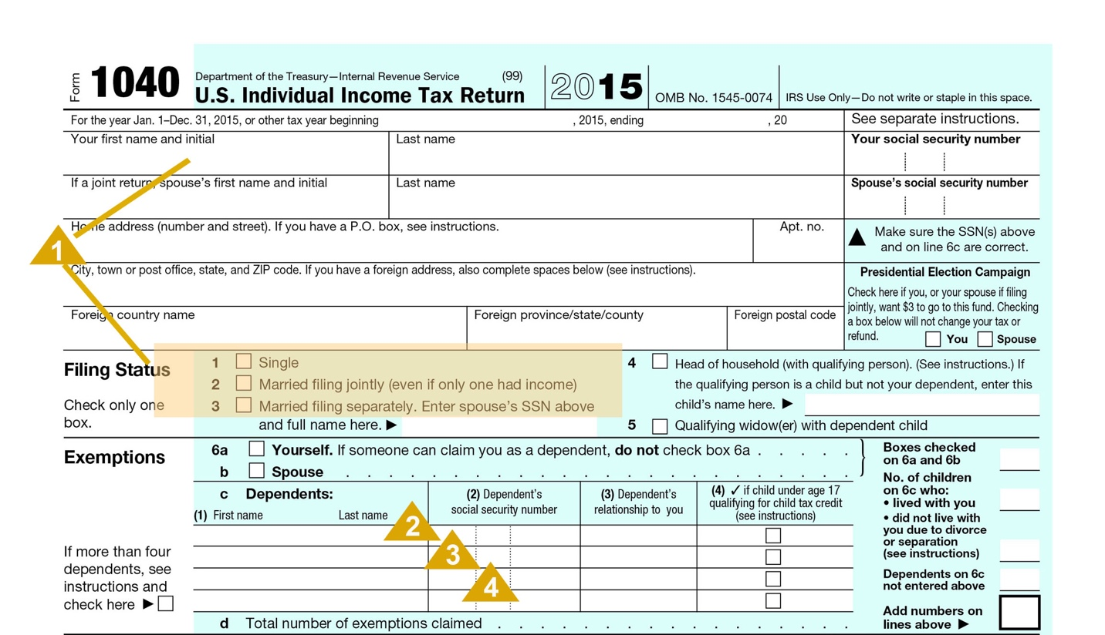

|  |
| --- |
| **1 – The Spouse**  If the client is married, the spouse’s name will appear on the tax return even if the couple does not file a “joint” income tax return. You need to gather additional information regarding the spouse, so be sure to inquire. If a couple files “Married Filing Separately,” why? Does the spouse work? Does the spouse take part in the investment decisions? Etc. |

|  |
| --- |
| **2 – Dependent Children**  Dependent children will be listed on line 6c. Since most people are interested in talking about their children, it provides a great opportunity to ask some open-ended questions about the children, their ages, and their activities. This discussion will give you a better feel for the lifestyle your client leads and may reveal day-to-day situations for which the client needs assistance. Potential needs to explore include:   * ***Educational savings*** for clients with younger children. If there is a former marriage, are there binding obligations regarding the child’s care and education? * ***General banking services for older children***, such as checking accounts, credit cards, and even mortgages and investment management accounts. * Does the child have any ***special care needs***? Often, parents will care for a special needs child in their home as long as possible. When this is the case, they may be interested in creating a Trust that would continue providing for the child’s care if the current situation changes. You might introduce consideration of a Special Needs Trust by asking an open-ended question that gets them to reflect on the risk of failing to plan for their deaths. For example, you might ask: “How have you addressed the need to continue care for your child if you and your spouse were killed in a common accident?”   ***Be sensitive to the possibility that a discussion about special care needs might raise uncomfortable feelings with a client***. If the client is willing to discuss this personal and sometimes difficult aspect of their life, let them talk and respond with understanding and additional questions. If you detect reticence to discuss the subject, just let it be - you can always come back later when you have built up more trust with the client.  Note that this area can be of great emotional and financial concern, possibly even a primary concern to your client. Advisors would do well to develop some understanding of the issues involving special needs children and develop a network of other professionals with specialized experience in this area. It’s a bigger market than most people realize. |

|  |
| --- |
| **3 – Dependent Parents**   * If a dependent is a parent, the client may be facing other issues. * Does the parent need elder care? * Are there significant medical expenses that are of a concern to the client? The parent could have assets that are being expended for medical care. Are those expenses being taken full advantage of? * Does the parent require in-home assistance? If so, is the client in compliance with payroll and tax reporting rules? * Is there an insurance need that your firm can fulfill? * The client may be considering a pre-planned funeral for the parent or pre-paid funeral arrangements. Sometimes working through a medical situation or through the death of a parent can spur the client to action, wanting to avoid a similar situation when the client reaches a similar age. * Is there a need for estate planning or elder care expertise? Have you developed a good network of estate planning and elder care specialists? |

|  |
| --- |
| **4 – Other Dependents**  If children have different last names than parents, there may be a remarriage with possible financial obligations or implications. Sometimes, the dependent named on the return may not be a member of the immediate family. For example, the dependent may be a grandchild or a niece or nephew. When inquiring as to the situation that put the individual in the care of the client, be aware that this may be a delicate situation and exercise great care in inquiring. The specific situation will dictate what other questions are asked. If possible, helpful information to obtain includes   * Is the dependent related to the client? If so, what is the relationship? * Is the inclusion of this individual in the household a permanent situation? * What is the age of the dependent and what special considerations are there? Take care in this area, as it, too, can raise some uncomfortable feelings. |

## Understanding Your Client’s Income

The next section of the tax return captures the gross income. Within this section, you should focus your attention on seven key areas. We will discuss these areas in more detail on the following pages.

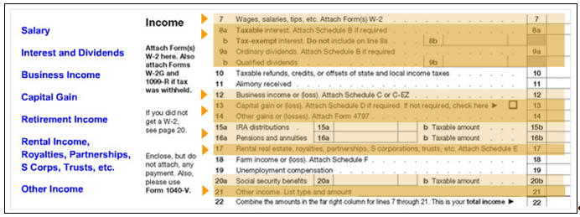

## Wages

The taxpayer’s wages and salary is found on line 7 of the tax return. While this item appears on a single line, the taxpayer’s compensation is far from one-dimensional. The wage amount on Line 7 could include regular salary, bonus amounts, stock option income, commission income, special pay allowances, and deferred income. Each of these various types of income brings with it an ability to plan and help the client. How do you discern these things?

To gain more insight into the client’s compensation, go to the attached W-2 Wage and Tax Statement. It may provide additional detail on the client’s compensation and help you identify additional opportunities. Of particular interest is Box 12, which may have one or more entries consisting of a letter followed by a dollar amount. For our purposes, we shall focus on specific letter entries you might look for.

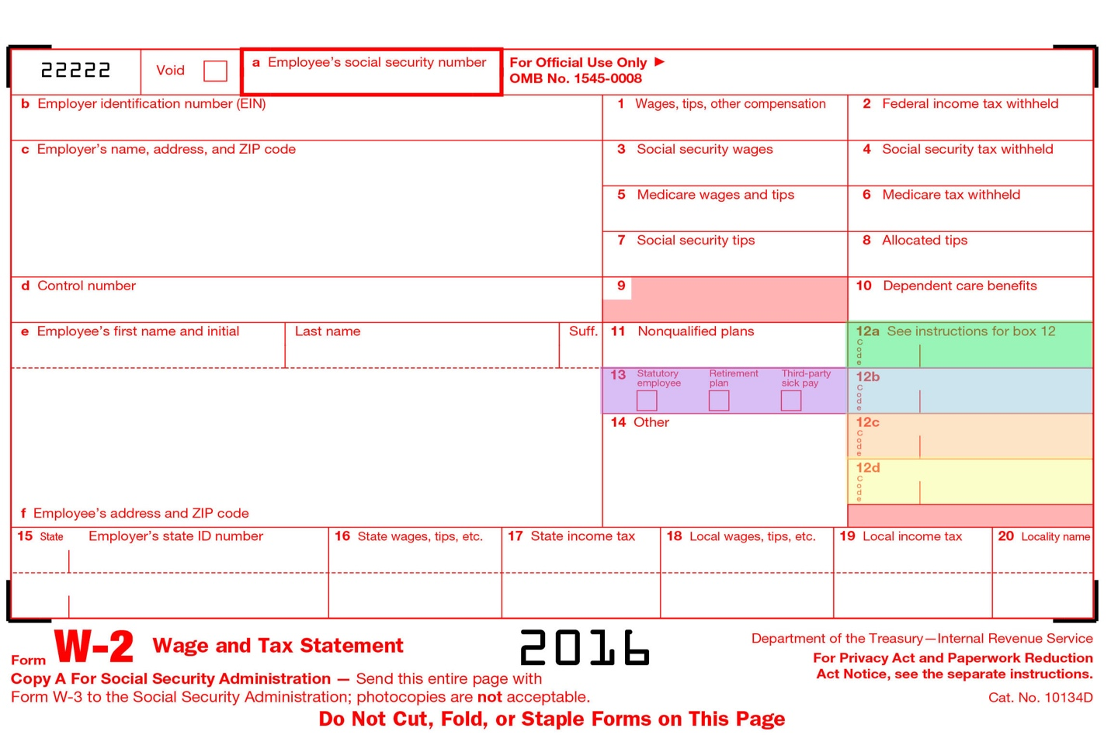

|  |
| --- |
| **12a – Insurance Planning**  This represents the cost of group term life insurance for coverage beyond $50,000. Further questions about this policy and others held by the client may help reveal the potential need for additional life insurance coverage. |

|  |
| --- |
| **12b – Retirement Planning**  These represent ***elective deferrals to various retirement plans***. Typically, you will see the letter D, which is associated with 401(k) plans. This information gives you added insight into how aggressively the person is saving for retirement. If you see no entries, then further inquiry on how the client is planning for retirement may reveal the need for additional assistance and/or guidance. You might begin the conversation by asking, “How are you maximizing tax-advantaged savings vehicles to defer income and save for retirement?” |

|  |
| --- |
| **12c – Education and Estate Planning**  This represents benefits that the employer paid under an ***adoption assistance program***. Its presence represents a significant life event for the client and, particularly if this is the first child, may open up the opportunity for a discussion regarding the client’s estate plan. It also creates an opportunity to discuss education planning. |

|  |
| --- |
| **12d – Stock Option Planning**  This represents income from the exercise of a **nonqualified stock option.** When these options are exercised, they typically generate a taxable event. If the client sold the stock after exercise, then the client had sufficient liquidity for the stock; but where did the balance of the cash go? Further inquiry on your part may reveal liquid funds that you could assist in investing. If the client is still holding the stock, it may represent a considerable concentration in the client’s portfolio, particularly if this represents one of several stock options. If that proves true, you may want to ask the client, “What steps have you taken to reduce the risk associated with concentrating so much of your net worth in one security?” This may provide an opportunity for you and your team to investigate the importance of asset allocation to help spread risk over a range of asset classes and investment sectors. |

|  |
| --- |
| **13 – Employer Contributions to a Health Savings Account**  Box 13 - In Box 12, you will get an indication of whether or not your client(s) is/are deferring income into an employer’s retirement plan. However, if the employee is in a noncontributory plan, it will not show up in Box 12, but if “Retirement Plan” in box 13 is checked, your client is probably in a retirement plan and may possibly limit deductions of contributions to a traditional IRA. |

## Learning about the Client’s Investments

Income from investments, in the form of interest and dividends, is found on lines 8 and 9 of the tax return. Let’s begin by examining the information to be learned in this section of the return and then examine how that information can help you identify potential investment planning opportunities with a client.

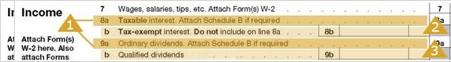

|  |  |  |
| --- | --- | --- |
| **1 – Taxable Interest and Ordinary Dividends**  The details for taxable interest and ordinary dividends will be found on Schedule B. Taxable interest (line 8a) is ***exclusive*** of tax-exempt interest (line 8b); however, ordinary dividends (line 9a) are ***inclusive*** of qualified dividends (line 9b).  There are two key questions to be answered by this Schedule.  scheduleb_0   |  | | --- | | **1 – What is the market value of investments?**  Using an estimated interest rate for bonds and an estimated dividend rate for stocks, it is possible to estimate the market value of each asset type.   * For bonds, you can use an average coupon rate for mid-term bonds. For example, the Dow Jones Corporate Bond Index will list, over the previous 5 years, an average coupon rate for 10-year corporate bonds. Assume that rate is 6.7%. By dividing the total interest on Schedule B by 6.7%, the advisor can estimate the amount of the investment. * For stocks, you can estimate the dividend rate as being from 2 to 3 percent (2.5% as an average). Simply divide the total dividends by the estimated rate to derive the estimate of the amount invested.   **Example:** If Schedule B shows interest income of $28,000 and dividends of $15,000, then the estimated value of these investments are:  Estimated bond investment = $28,000 / .067 = $418,000  Estimated stock investment = $15,000 /.025 = $600,000 |  |  | | --- | | **2 – Where are the assets invested?**  A review of the Schedule B will reveal the payers of the interest and dividends. Sometimes, this Schedule will list each individual security. However, since financial institutions will mail out a single 1099 to provide the interest and dividends for an entire account, **it is more common to see the name of the institution where the assets are held**. This is particularly valuable information, as it identifies your current competition. | |

|  |
| --- |
| **2 – Tax-Exempt Interest**  The taxpayer is not required to provide details of tax-exempt interest. Therefore, line 8b may be the only information you will find regarding tax-exempt interest.  As with taxable interest and dividends, we can also estimate the value of the underlying assets. Typically, the rate for mid-term AAA rated municipal bonds should be used. April 2014, 10-year municipal bonds had a yield of approximately 2%.  **Example**: If line 8b indicates $5,000 of tax-exempt interest, then the estimated value of the investment is: Estimated tax-free investments = $5,000 / .02 = $250,000 |

|  |
| --- |
| **3 – Qualified Dividends**  The dividends paid on most stocks, when properly held, qualify for a special tax rate. Line 9b will give an indication of those dividends that qualify for this reduced rate. The current difference in rates is 20%, which is quite significant.  Review the ratio of qualified dividends to ordinary dividends. If qualified dividends are low relative to ordinary dividends, this could be a sign of excessive sales in the account, which prevents stocks from being held long enough to qualify for the special rate. However, do not jump to that conclusion because there may be other explanations, such as the fact that preferred dividends are not eligible for qualified dividend treatment. |

## Creating Investment Management Opportunities

Based on the information you gather on the interest and dividend section of the tax return, it is possible to identify a preliminary asset allocation. For example, on the previous page we provide illustrations for bonds and stocks that would provide the preliminary asset allocation (below).

|  |  |  |
| --- | --- | --- |
| **Taxable Bonds** | $418,000 | 33% |
| **Tax-free Bonds** | $250,000 | 20% |
| **Stocks** | $600,000 | 47% |

As we continue through the return, we will point out other sections of the return that will provide additional information regarding investments.

Altogether, this investment information will provide you with sufficient information to initiate an informed investment discussion with the client. During the course of that discussion, you can ask fact-finding questions that will clarify your understanding and help you determine potential needs. You will also have opportunities to ask open-ended questions that help raise doubt in the client’s mind about his or her current situation, thereby helping the client see the shortcomings that you find in the current portfolio and foster interest in solutions you can offer.

Here are some key questions to consider asking. Note that we have deliberately positioned some of these questions to place responsibility on the current advisor, rather than running the risk of embarrassing the client.

|  |  |
| --- | --- |
| DocumentationIcon_32px | **What are your goals for your investments?** |
| **Answer:** This question opens up a general discussion of the investment portfolio, allowing you to gain insight into the client’s needs, objectives, and concerns, while also allowing you to ask further fact-finding questions like:   * Who do you rely on for investment advice? * What are your short-term and long-term financial needs? * How much income must your investments generate to meet your current needs? * What are the specific holdings in your portfolio? * How were these investments selected? * What do you value in your relationships with your current investment manager(s)? * What changes would you make in these relationships?   This discussion will generally shed light on whether or not the invested assets are properly allocated, adequately diversified, and at the proper level of risk. As these opportunities present themselves, you can further develop the conversation by asking some doubt-raising questions like:   * How has your advisor worked with you to establish clearly defined investment objectives? * How has your advisor worked with you to select investments that are appropriate for your objectives?   Such doubt-raising questions will help the client recognize a need that may seem obvious to you, and incline the client to be interested in solutions you may offer. | |

|  |  |
| --- | --- |
| DocumentationIcon_32px | **How has your current advisor worked with you to identify the proper asset allocation for your portfolio?** |
| **Answer:** As you learn more about the client’s needs and objectives, it may become apparent that the asset allocation is inappropriate. This is an excellent doubt-raising question by which you can introduce a discussion regarding asset allocation. | |

|  |  |  |  |
| --- | --- | --- | --- |
| DocumentationIcon_32px | | **How has your advisor worked with you to maximize after-tax returns?** | |
| **Answer:** Municipal bonds generally yield an interest rate below corporate bond rates. Yet, due to the tax-free nature of many of these bonds, tax savings can at times more than compensate for the lost yield. If a client is in a lower tax bracket, but holding municipal bonds, then the client is not being adequately compensated for the lower yield. Similarly, if a client is in a higher tax bracket, but holding taxable bonds, then the client’s after-tax income can be increased through a shift to municipal bonds.  To identify what is appropriate for your client, you need to know the client’s marginal tax rate. This can be found by looking at the back of Form 1040 to find the client’s taxable income and then locating that income on a tax rate schedule.  **Example**. Upon examining the 2016 return of a married couple filing jointly, you learn that the taxable income is $250,000. Locating this income on the following rate table reveals that the marginal bracket is 33%.   |  |  |  |  |  |  |  |  |  |  |  |  |  |  |  |  |  | | --- | --- | --- | --- | --- | --- | --- | --- | --- | --- | --- | --- | --- | --- | --- | --- | --- | | |  |  | | --- | --- | | **If Taxable Income Is:** | **The Tax Is:** | | Not over $18,550 | 10% of the taxable income | | Over $18,550 but not over $74,900 | $1,855 plus $15% of the excess over $18,550 | | Over $75,300 but not over $151,900 | $10,367.50 plus 25% of the excess over $75,300 | | Over $151,900 but not over $231,450 | $29,517.50 plus 28% of the excess over $151,900 | | Over $231,450 but not over $413,350 | $51,791.50 plus 33% of the excess over $231,450 | | Over $413,350 but not over $466,950 | $111,818.50 plus 35% of the excess over $413,350 | | Over $466,950 | $130,578.50 plus 39.6% of the excess over $466,950 | |   By analyzing the after-tax return of taxable and tax-free investments at a 33% marginal bracket, you can make the determination as to whether a shift in the bond portfolio is appropriate and whether or not this doubt-raising question should be asked. | | | |
| DocumentationIcon_32px | **What process does your advisor use to select securities for your portfolio?** | |
| **Answer:** Often, you will discover that there is no clear process at work in selecting (or selling) securities, resulting in emotional decision-making that leads to sub-par performance. If the client is unable to clearly articulate the process their current advisor(s) uses to buy and sell securities in the portfolio, they need to talk with you and members of your team further. | | |
| DocumentationIcon_32px | **How has your advisor worked with you to ensure your portfolio is appropriately diversified?** | |
| **Answer:** It is very common that individuals will either have much of their portfolio invested in a few securities (lack of diversification) or too many funds and/or securities in their portfolio (over-diversification). Asking this question will identify whether or not the client is actively managing this important issue. If they cannot effectively answer the question, it is probably in their best interest that you and your team engage in a review of their portfolio to ensure it is in fact properly diversified. | | |

## Capital Gains

The information in the capital gain section reflects sales of assets. The important pieces of information in this section are reported on Schedule D, a copy of which can be viewed below.

17-capitalgain

|  |  |
| --- | --- |
|  |  |

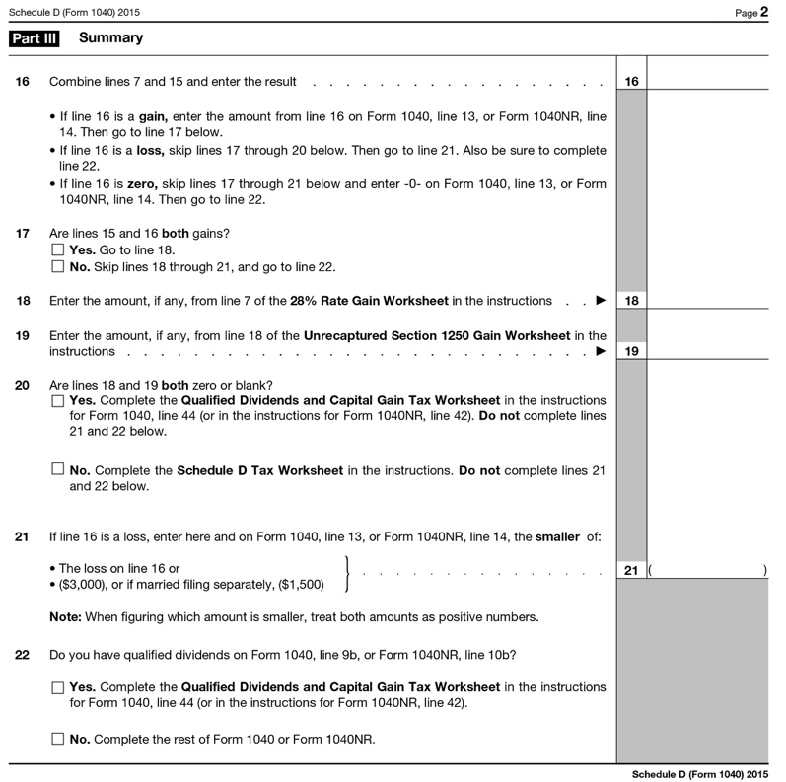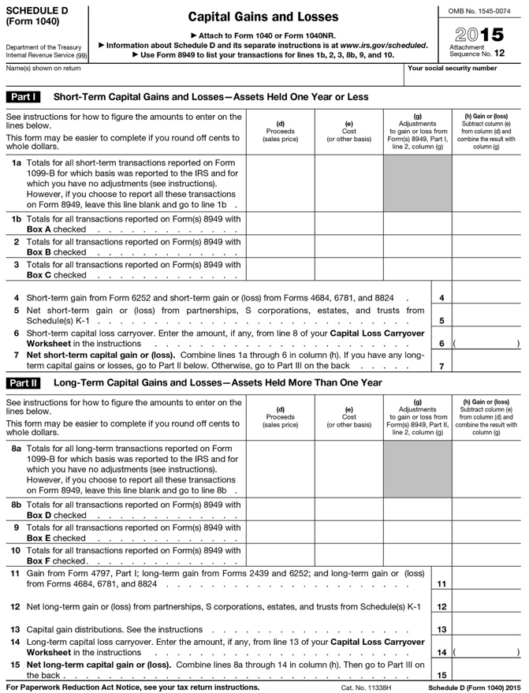

In reviewing this schedule, you should be more concerned with why the assets were sold rather than what was sold or when the sale occurred. In particular, you can answer these two questions by examining Schedule D.

|  |  |
| --- | --- |
| DocumentationIcon_32px | **How long were assets held prior to sale?** |
| **Answer:** A large volume of short-term sales could indicate an aggressive investment posture. They could also indicate excessive trading on the part of an investment manager. You might further explore this with the client by asking, “How has your advisor concluded it is in your best interest to have a short-term investment strategy?” | |
| DocumentationIcon_32px | **Was there a large liquidity event in the client’s life?** |
| **Answer:** For example, you may see that the client sold a business or that a large holding was liquidated. These events should prompt further inquiry with the client, which may reveal that investment opportunities still exist regarding the proceeds from the sale. | |

Questions that you might ask the client to gain further clarification include:

|  |
| --- |
| **Effective Questions**   * What was the motivating factor for the sale? * Was the sale part of a structured plan? * Did the client authorize the sale or did a financial consultant have discretion in the account? * Was the portfolio being rebalanced or was the client reducing a concentrated stock position? |

These questions should lead to a discussion about Financial Planning and proper use of cash in light of goals. It could also lead very nicely into a discussion about asset choice, assumption of risk and general investment education.

A good question to get this discussion going is, “How does your advisor determine when it is appropriate to sell a security?” Chances are the client will not know the answer, which opens the door for you to position your approach

## Business Banking Opportunities

As discussed previously in this course, business owners represent a highly attractive segment of the affluent market due to their vast array of both personal and business planning needs. However, business owners are typically very busy people who too often set aside little time to ensure their financial affairs are in order. By analyzing Schedule C of the tax return, you can identify if in fact the individual owns a business as well as other vital information that will enable you to more effectively engage the client in a targeted and relevant conversation. Let’s look at some of the key information that can be gleaned from this section of the return.

Business income is reported on line 12 of Form 1040.

18-bankingopp

The business income detail can be found on Schedule C, a copy of which can be viewed below.

|  |  |
| --- | --- |
|  |  |

|  |  |
| --- | --- |
| Front | Back |

For our purposes, do not be overly concerned with understanding everything you see on Schedule C. Think of it is a place where you can identify what the client is interested in or what the client is familiar with. People generally like to talk about themselves, particularly if they enjoy their profession. These discussions can help create common ground between you and the client.

As you review the schedule, here are some questions to keep in mind.

|  |  |
| --- | --- |
| DocumentationIcon_32px | **How aggressive is the person with deducting expenses?** |
| **Answer:** Take a closer look at the expenses in Part II of the Schedule. In particular, look at the ratio of expenses to income. Some business owners can be extremely aggressive in finding expenses that can be deducted. If this ratio is high, then you can be pretty sure that the client will be equally aggressive regarding investments in the stock market. | |

|  |  |
| --- | --- |
| DocumentationIcon_32px | **Are there capital needs?** |
| **Answer:** Identify potential capital needs for the business by asking questions such as:   * How are your current loans / lines of credit presently structured? * What liquidity needs do you anticipate for the business in the next 12 months? | |

|  |  |
| --- | --- |
| DocumentationIcon_32px | **Are there deposit / cash management needs?** |
| **Answer:** Businesses obviously have core banking needs, including business banking and checking accounts as well as cash management strategies. Identify opportunities by asking questions such as:   * Who do you bank with currently? * What are the annual revenues of the business? * How do you manage your cash to optimize after-tax yields? | | |

## Identifying Retirement Planning Opportunities

Older clients are particularly interested in the issue of retirement planning, and the client’s tax return provides a wealth of information about their current plans. Let’s examine how you can gather important information regarding your client’s retirement planning from their tax return.

Retirement income includes distributions from IRA plans, company-sponsored plans, pension plans and Social Security. This information can be found on these highlighted lines of Form 1040:

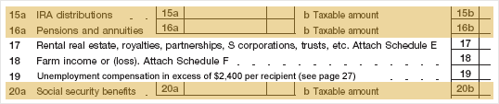

If you see entries here, then there is a potential opportunity to assist the client with retirement income planning. To discern this need, you will need to gather more facts by asking questions.

|  |
| --- |
| **Effective Questions**   * When did you begin taking distributions from your retirement plan? * What are your income needs during retirement? * Are you generating sufficient income from your retirement plans? * How have you structured your retirement portfolio to ensure you do not outlive your assets? * What additional benefits will you receive that are not being paid in the current year? |

## Rental Income, Royalties, Partnerships, S Corporations, Trusts, etc.

20-rental

Line 17 shows income from rental real est

|  |  |
| --- | --- |
|  |  |

ate, partnerships, S corporations, trusts, etc. The detail for these sources of income can be found on Schedule E, a copy of which can be viewed below.

This Schedule is broken into five sections, but for our purposes you need only concern yourself with the first three sections.

|  |  |  |
| --- | --- | --- |
| **Section I**  **Income or Loss from Rental Real Estate and Royalties**     |  | | --- | | **1 – What, Where, and How Much?**  Here you will learn:   * What kind of property is owned (e.g., a commercial building, a house, oil and gas rights, etc.). * Where the property is located. * How much income it generates.   Depending upon the assets you see, here are some questions and considerations you might explore:   * **"Is the property being held primarily to generate income or for appreciation purposes?"** * **“How is the mortgage on this property structured?”** You may be able to propose a better solution. * **“Are you considering selling the property?”** If so, a tax-free exchange could be attractive to the client. * **"How will this piece of property be handled in the estate?”** Real estate can be tricky when dividing an estate. * **"Does this investment fit into the overall portfolio when considering the client’s goals and needs?"** Often, affluent clients have a significant amount of their net worth tied up in real estate investments which can be problematic if they do not consistently review their holdings to ensure they are well diversified. |  |  | | --- | | **2 – Expenses**  These are the expenses associated with the income producing property. Aside from depreciation expense, these items generally require a cash outlay. When compared to the income generated from the property, these will give you an idea of the cash flow from the property, and whether or not there is need for cash from other sources. | |

|  |  |
| --- | --- |
| **Section II**  **Income or Loss from Partnerships and S Corporations**     |  | | --- | | **1 – Partnerships and S Corporations**  This section reveals any investments in partnerships and S Corporations that generated a K-1 tax reporting form. All you are interested in at this point is identifying whether or not these are part of the client’s holdings. If so, then you should recognize that these types of investments generate all sorts of issues:   * What is the nature of the business and is the client directly involved in the day-to-day business? * What is the client’s long-term intention with regard to any of the investments in this area? * How are these investments managed in context with the overall portfolio? | |

|  |  |
| --- | --- |
| **Section III**  **Income or Loss from Estates or Trusts**     |  | | --- | | **1 – Estates and Trusts**  Trusts and estates also generate K-1 tax reporting to beneficiaries. If you see an estate listed, find out what assets will ultimately be distributed to the client. This may present an opportunity to assist the client with investing the inheritance.  If you see a trust listed, find out more about the trust.   * **What are the terms of the trust?** * **When does the trust terminate?** Some trusts have specific termination dates, which allow planning for the disbursement. * **Who acts as trustee?** If it is a family member, there may be an opportunity for providing professional services to the trustee. | |

## Other Income

The “other” income section is reported on the line on the tax return with the same name – “Other Income”.



|  |  |
| --- | --- |
| **Overview** | Director’s fees and trustee fees are the two most common entries found here. Knowledge of these items will give you an idea of where the client spends time. |
| **Directors** | In recent years, greater scrutiny has been focused on Boards of publicly traded companies. As such, a director is held to a higher standard of performance and an individual holding such a position will spend more time now than someone in such a position would have spent five years ago. Since these positions are more time-consuming and carry a much greater likelihood of public criticism, directors are more carefully chosen and are more thoughtful in acceptance. If a client is a current board member, it tells the consultant that the client is serious about the business affiliation and directorship duties. |
| **Trustees** | Trustee fees generally indicate a level of trust that the client enjoys within the family or close friends. Since the job of trustee is not subject to public scrutiny, it is sometimes a thankless job. Furthermore, the duties that accompany the fees are often unpleasant and can be quite time consuming. You may be able to offer professional services to assist the client in fulfilling the trustee duties.  The key to suggesting assistance is to find out how comfortable the client is with the duties that accompany the trustee title. It is also possible that the client has never seriously considered the liability associated with acting as trustee.  Begin by asking some fact-based questions. These will help you surface potential needs.   * When was the trust created? * How did the trust come about (due to death or some other event)? * Who are the beneficiaries? * What is the size of the trust? * Can the client name a successor trustee? * What does the document say about the client’s power to name a co-trustee or an investment agent?   Once you have a clearer picture of the nature of the trust, asking more open ended, doubt-raising questions may introduce opportunities for you to provide assistance. Consider the following examples:   * How do you feel about the risks associated with acting as trustee? * How have you balanced your desire to have close family relations against the risk that your decisions as trustee could be divisive (if the beneficiaries are family members)? |

## Above the Line Deductions

Unlike individuals in the U.S., not all deductions are created equal. Some provide much more benefit than others do. The Internal Revenue Code divides deductions into two categories: those “above the line” and those “below the line.” “The line” is a magic number called ***Adjusted Gross Income (AGI)*** and it appears twice on the tax return. It is the last number on the first page and the first number on the last page. Adjusted Gross Income is used throughout the return to calculate the deductibility of expenses, the deductibility of exemptions, the calculation of tax and the application of tax credits. Generally speaking, deductions “above the line” provide more benefit than those “below the line” due to the importance of the AGI number.

What are “above the line” deductions? They are the deductions that are taken to transform Gross Income into Adjusted Gross Income. The three primary deductions of importance to us are those allowed for: (1) IRA and other retirement plan contributions; (2) self-employed health insurance payments; and (3) education.

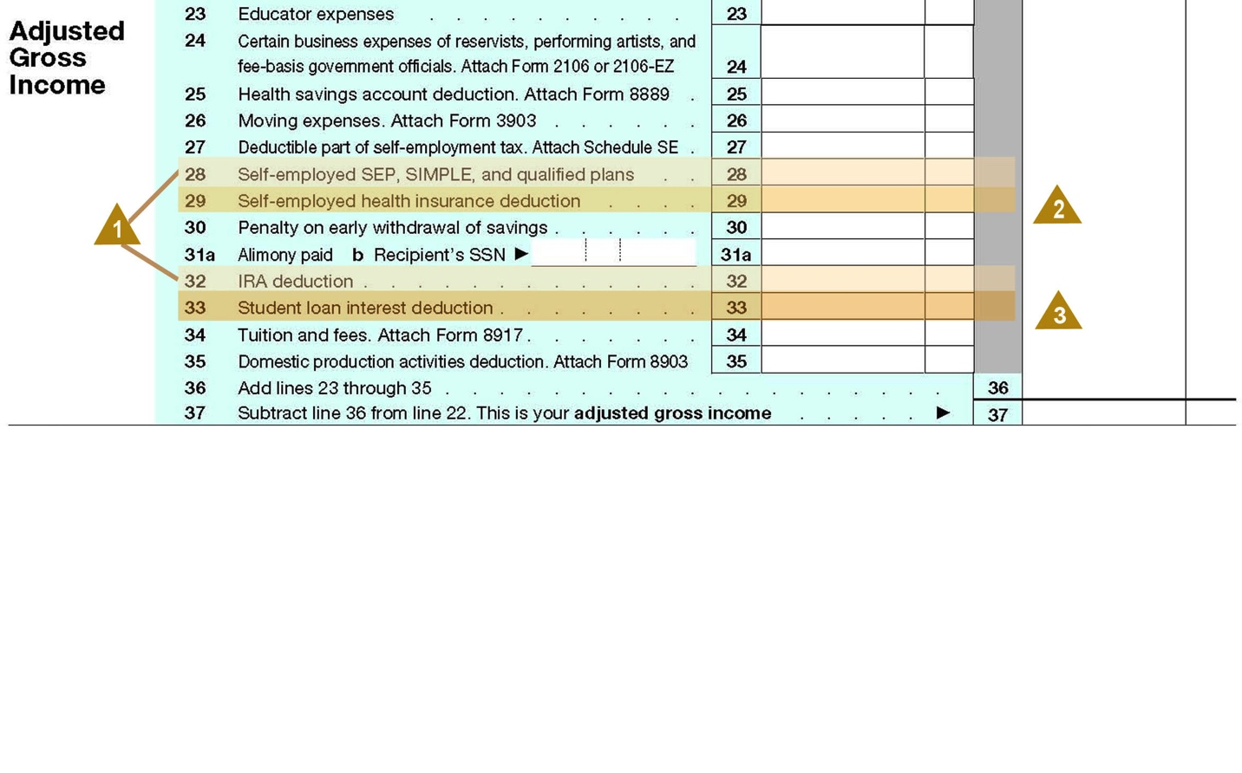

|  |
| --- |
| **1 – Retirement Planning Information**  With regard to retirement plan contributions, the client is using cash to save for retirement. You should ask about the client’s plans for retirement, timing for retirement and the need for additional savings. If the plan includes an IRA, is the client happy with the current provider? Has the asset allocation been properly adhered to in light of the stated goals? Is there a rollover opportunity? |

|  |
| --- |
| **2 – Insurance Information**  Self-employed health insurance payments indicate the client is a business owner. This information should be included with other information on the return regarding the business, and is useful in discussing other business-related insurance needs such as life insurance and umbrella liability coverage. |

|  |
| --- |
| **3 – Education Planning Information**  A deduction for education expenses indicates that someone in the household is engaged in higher learning. Who is that person? Is a dependent, the client, or a spouse in school? Is additional funding needed for education expenses? You should discuss the various lending products that might fill a cash flow need for the client. The presence of education expenses can also lead into a discussion of future cash flow needs and plans for career changes. |

## Below the Line Deductions

What are “below the line” deductions? These are deductions most commonly referred to as itemized deductions, by which AGI is adjusted to derive taxable income. These deductions are made up of medical expenses, taxes, interest, charitable contributions, casualty losses and miscellaneous deductions. While itemized deductions are reported on a single line of the return, the details behind the deductions are shown on **Schedule A**, which shall be examined more closely below.

23-below

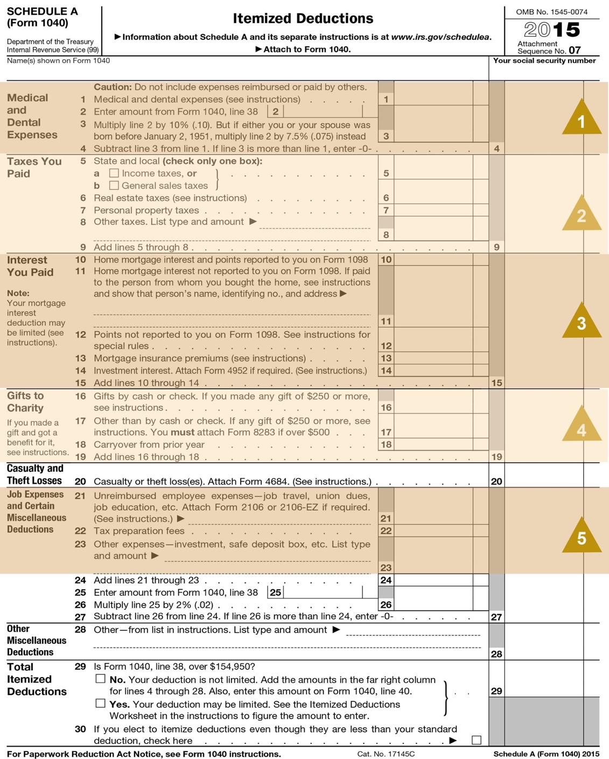

|  |
| --- |
| **1 – Medical Expense**  It is difficult to receive a tax benefit from medical expenses due to a “floor” the IRS requires filers to meet prior to any benefit. Unless the client is paying for nursing home expenses or has experienced a catastrophic medical event, most taxpayers are unable to gain benefit from medical expenses. Thus, an entry in this area indicates long-term medical care costs or a one-time event. Inquiry should be made to identify any possible implications regarding estate planning needs. |

|  |
| --- |
| **2 - Taxes**  Yes, taxes are deductible. Which ones? State income tax payments, real estate taxes, and personal property taxes are most common in this area. You can learn several things from this section:   * You can identify the person’s home state based on the state income tax payments. * The payment of real estate taxes indicates a possible mortgage opportunity. In fact, further discussion about what type of property is generating the real estate taxes could reveal multiple properties, such as a main home and a vacation property, all mortgage opportunities.   The presence of state income taxes serves as a reminder to consider both Federal and State taxes when examining the tax effectiveness of investments. |

|  |
| --- |
| **3 – Interest Expense**  The presence of interest expense should always lead to a discussion of mortgage products. In doing so, you should be mindful of the use of the proceeds and the ability to deduct the interest expense. Even though mortgage interest is reported on a tax return, it doesn’t mean it is always deductible. The general rules for deducting interest expense take into consideration the purpose of the loan. If the proceeds of the loan are used for personal expenses, the interest is generally not deductible. The exception to the rule is a mortgage on the main home. If the main home secures the loan, then the interest is deductible. Most people think of the exception as the general rule because they have a mortgage on their home.  Investment interest is also reported in this section. The rules regarding the deductibility of investment interest expense changed in 2003. If the client has a margin account, the interest expenses related to that line of credit may no longer provide a tax benefit. For example, the interest expense is only deductible to the extent that the client has net investment income, such as interest, dividends, and rental income. However, with the creation of “qualified dividends” in 2003, these dividends are no longer included in net investment income and the client may be left with insufficient investment income by which to deduct the interest expense. If that is the case, you may be able to offer other lending options and products (such as a home equity line of credit) that may reduce the overall cost of borrowing for the client. |

|  |
| --- |
| **4 – Charitable Contributions**  Charitable contributions indicate the client’s philanthropic intentions. Large deductions could lead to a discussion of the benefits of a charitable trust, a private foundation, or a community foundation as alternatives to outright gifting. Also of importance is the nature of the property being contributed.  A number of fact-finding questions are appropriate regarding this matter, some of which you can discern without even asking the question:   * Is cash being used? * Are there other assets that would serve this purpose better? * Did the client contribute more than was deductible in one year and is there a carry forward of the benefit? * Does the client realize when the deduction provides benefits? * What are the client’s long-term intentions for charitable contributions? * Are those intentions reflected in the client’s day-to-day activities, in the portfolio of investments, and in the estate plan?   By gathering this information, you can use this topic to open a discussion regarding the next generation of a wealthy client. For example, you might ask an open-ended question like, “How do you balance your desire to make charitable contributions against your desire to leave behind an estate for your family?” The client might be surprised to find that there are techniques available to maximize the lifetime benefit of making gifts to charities (e.g., gifting appreciated property, charitable remainder trusts, etc.), while also preserving the estate for loved ones (e.g., using the proceeds from a charitable remainder trust to purchase life insurance). You should be prepared to discuss these options with the client. There are many planning opportunities for charitable contributions and the consultant should discuss these options with the client. |

|  |
| --- |
| **5 – Miscellaneous Itemized Deductions**  Last are miscellaneous itemized deductions. The tax preparation fee and investment/trust fees are reported here. The consultant can get an idea of what the competition is billing for investment management and for trust services. You should discern the answer to the following questions:   * What do you value in your relationship with these advisors? * What changes would you make in these relationships? * How have you evaluated the fees they are charging to ensure they are competitive? |

## Conclusion

As discussed throughout this course, affluent clients are seeking to build relationships with advisors that deliver proactive financial advice.

Take time to review the material covered in this course and develop a specific and targeted plan you can employ to capitalize on the strategies outlined in this course to serve your clients.

This course has outlined many effective strategies for identifying opportunities to deepen banking relationships by:

* Identifying additional banking opportunities.
* Using key sources of financial information to identify additional opportunities to serve your clients in a more comprehensive manner.

|  |
| --- |
| **Review Guide** We have covered a lot of material in a short time, and you may feel a bit overwhelmed with all the things to remember. To assist you with your next review of a client’s Form 1040, we have created a Review Guide [next page], which may be viewed below. |

### Form 1040 Review Guide

The following guide is for use in identifying planning opportunities through a review of a client’s Federal Income Tax Return. The headings and line numbers parallel the tax form.

|  |
| --- |
| **Filing Status** |
| **Label; Line 2 – What is the name of the spouse?** |

|  |
| --- |
| **Exemptions** |
| **Who are the dependents?**   * For children – Potential needs are educational savings, banking needs of older children, or special care needs. * For parents – Potential needs are elder care, investment management of the parent’s assets, or insurance. * For others – Needs will be specific to the situation that has created the dependency. |

|  |
| --- |
| **Income** |
| **What is the salary or compensation?**   * See if any of these codes are in boxes 12a through 12d of the attached W-2 Wage and Tax Statement:   ***C = Group term life insurance beyond $50,000.*** What other life insurance does the client have? Is it adequate?  ***D, E, F, G, H, S = Elective deferrals to various retirement plans.*** Is the client maximizing tax-advantaged opportunities to defer income and save for retirement?  ***T – Benefits paid under an adoption assistance program.*** This life-changing event opens up the possibility to discuss estate planning and education planning.  ***V –******Income from the exercise of a nonqualified stock option.*** Such sales may generate liquidity needs and/or investment management needs.  ***W -*** ***Employer contributions to a health savings account.*** Is the client maximizing the efficiency of his medical coverage? How extensive are his employee benefits? What provisions has the client made for the potential risk of disability?  **What are the client’s investments?** Examine Schedule B for details.   * From the level and type of income, estimate the value of the assets and how they are allocated. * Look at where the assets are held. This is your competition. * Is the client taking advantage of qualified dividend rates, or are assets being sold too soon? * ***Key questions to ask are:***   + What are your goals for your investments?   + How has your current advisor worked with you to identify the proper asset allocation for your investments?   + How has your advisor worked with you to maximize after-tax returns?   + What process does your advisor use to select securities for your portfolio?   + How has your advisor worked with you to ensure your investments are appropriately diversified?   **Does the client have business income?** If so, review Schedule C.   * Is the client aggressive in deducting expenses? * Are there capital needs associated with the business? * Are there estate planning needs associated with the business?   **Does the client have capital gains or losses?** Details are found on Schedule D.   * How long were assets held prior to sale? If there were a lot of short-term gains, you might ask: “How has your advisor concluded it is in your best interest to have a short-term investment strategy?” * Was there a large liquidity event? This should prompt further inquiry to reveal potential investment opportunities. * A good open-ended question to ask is, “How does your advisor determine when it is appropriate to sell a security?”   **Is the client receiving retirement and/or Social Security income?** If so, ask some fact-finding questions to discern the overall retirement plan and the client’s need for retirement income. Then ask some open-ended questions like:   * How has your advisor structured your portfolio so that you don’t have to worry about your cash needs? * How has your advisor structured your portfolio to provide the ongoing income you need without having to resort to untimely sales of assets? * Is the client receiving Social Security income for retirement benefits or for another reason?   **Does the client have income or loss from rental real estate,** **partnerships, S corporations, or trusts?** If so, ask fact-finding questions to learn more about these items and the client’s involvement with them. Key issues to discern include:   * Are there expenses associated with these that might impact the client’s cash flow? * Do these items make sense in the client’s overall portfolio? * Is the client anticipating a sizeable future distribution for which you could provide investment assistance?   **Is the client receiving any “other” income?** In particular, look for trustee fees. The client may need assistance in fulfilling trustee duties or may prefer to reduce the risk associated with acting as trustee. |

|  |
| --- |
| **Adjusted Gross Income** |
| **Is the client saving for retirement?** Ask about the client’s plans for retirement, timing for retirement and the need for additional savings.   * If the plan includes an IRA, is the client happy with the current provider? * Is there a rollover opportunity?   **Is the client paying for self-employed health insurance?** If so, you should explore other potential business-related insurance needs, such as life insurance and liability coverage.  **Is there an educational deduction?** If so, there may be cash flow needs. |

|  |
| --- |
| **Tax and Credits** |
| **Did the client itemize deductions?** If so, look at Schedule A.   * Schedule A, Line 4 – Was there a deduction for medical expenses? If so, find out if this represents a one-time event or a long-term care need. * Schedule A, Lines 10 and 11 – Are there deductions for mortgage interest? If so, there may be an opportunity for refinancing. * Schedule A, Line 14 – Was there an investment interest deduction? Will the client have sufficient investment income by which to deduct interest expenses in the future? * Schedule A, Line 19 – Is the client charitably inclined? If so, examine the types of property being given, the client’s ability to maximize the current benefit of such gifts, and the long-term goals of the client. This may open up a broader discussion of various planned giving approaches. * Schedule A, Lines 22 and 23 – What are other professionals charging for their services? What levels of services are being offered and is the client happy with them? Can you do better?   **Is there an AMT tax?** If so, examine the following lines on Form 6251:   * Form 6251, Line 4 – Is the client using a home equity line for purposes other than buying, building, or improving a home? If so, this may be contributing to the AMT tax. You may be able to offer a preferable means of financing. * Form 6251, Line 12 – Does the client have interest from a private activity bond? If so, this may be contributing to the AMT tax. You may be able to offer an alternative investment. * Form 6251, Line 14 – Did the client exercise incentive stock options? If so, the client may have a number of associated needs:   + Liquidity with which to pay the additional taxes.   + Professional assistance in planning for future exercises.   + Professional investment management that will reduce the risk of holding stock concentrations and properly diversify investments once the holdings are liquidated.   **Is there a foreign tax credit?** If not, the client may not be realizing the benefit of investing in international or global funds.  If this is confirmed, you might ask, “How has your advisor worked with you to make the determination that you should not participate in the diversification and additional return that is available by adding international investments to your portfolio?” |

|  |
| --- |
| **Payments** |
| **Is the client making estimated tax payments?** If so, you might be able to assist with providing a line of credit or restructuring the portfolio to provide the necessary cash flow. |